EXERCISE NO: 3
DATE:24.10.2020
AIM:
To write a python program to remove and print every second number from the list of numbers until the list becomes empty.

PROGRAM:
def removenumber(no):
p = 2 - 1
id = 0
lenoflist = (len(no))
while lenoflist > 0:
id = (p + id) % lenoflist
print(no.pop(id))
lenoflist -= 1
A=list()
n=int(input("Enter the size:"))
print("Enter the n")
for i in range(int(n)):
p=int(input(""))
A.append(int(p))
print("After remove ")
removenumber(A)
LINK:
http://103.53.53.18/mod/vpl/forms/submissionview.php?id=231&userid=1757

OUTPUT:

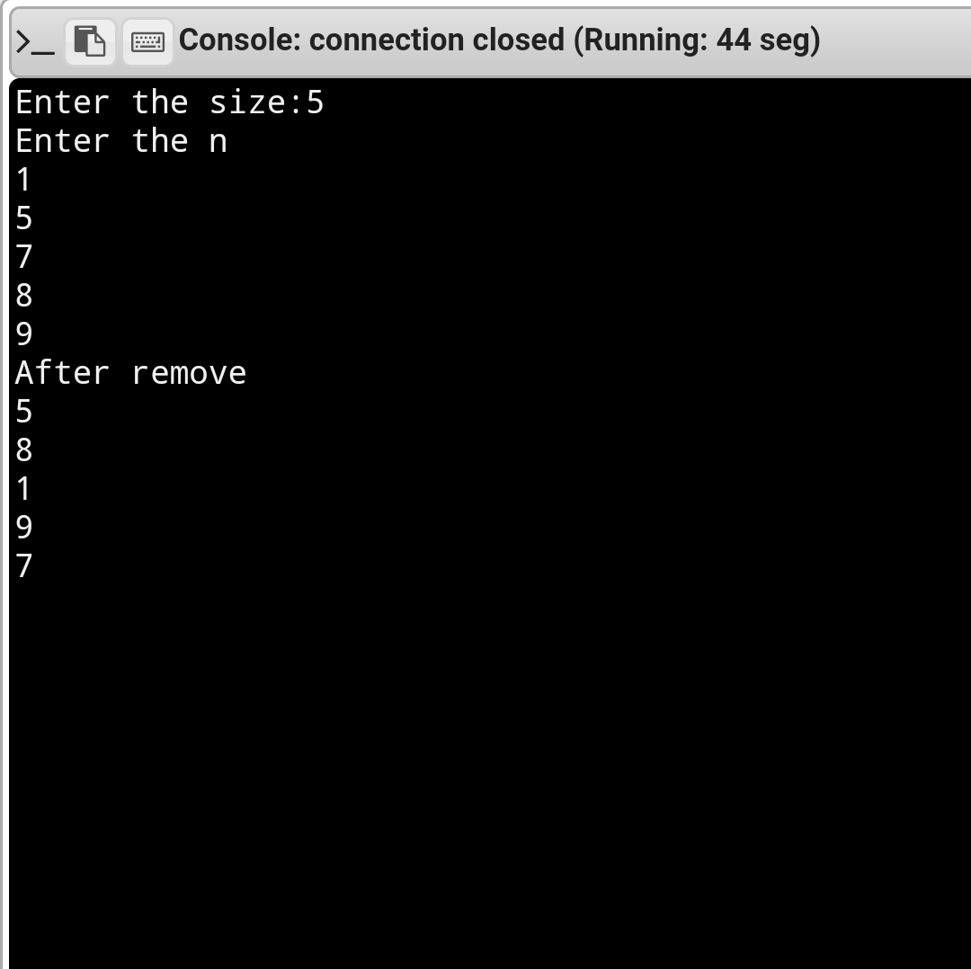
RESULT:
Removing and printing every second number from the list of numbers is done.

